

### Name: KHLORP VEAK

**Class: C**

**Print: Monday , May , 15 ,2023**

**I** **can do it**

**I​** **will struggle**

Name: KHLORP VEAK 1

1. you first Week at PNC: 2

2. Description of the city will include my picture 3

3. If you were a fruit. 4

4. Want to see yourself in 5 years. 5

### You first week at PNC:

The first week at PNC was a strange feeling to meet new people on PNC. feeling excited to come to PNC. We come from different provinces.

* **Difficult to adapt:**

Because we are the first to meet and come from different provinces And also difficult to talk​ And when we were together for a long time, we got to know each other better and we dared to talk to each other happily. Sometimes we joke a lot, not carelessly.

Learning is somewhat difficult:

* **A little difficult because it is a new lesson for me a lot.**

The hardest lesson for me was English. difficult to talk, difficult to listen and difficult to write.

* **Spending:**

The cost of food and other items is expensive, and on Saturdays and Sundays we make our own meals.

* **Living in a group:**

Living in a group is difficult because we have never lived in a group. The house used to sleep in a room alone. But it is also a problem.

* **Talking to people around you:**

Two because​ I was the first person who could not speak fluently in communication. I am a quiet person. Sometimes quiet.

* **What I face a lot of problems :**
* Miss home
* Miss sister
* Miss prother
* Momder
* Father

### Description of the city will include my picture

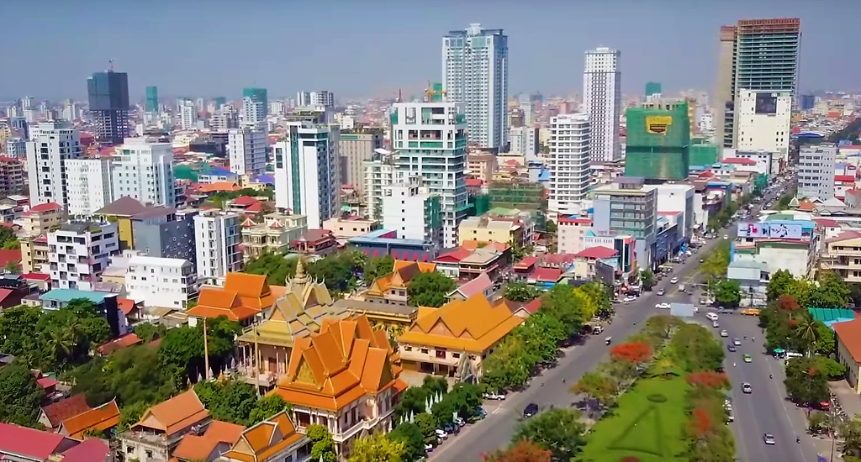Phnom Penh, Cambodia’s busy capital, sits at the junction of the Mekong and Tonlé Sap rivers. It was a hub for both the Khmer Empire and French colonialists. On its walkable riverfront, lined with parks, restaurants and bars, are the ornate Royal Palace, Silver Pagoda and the National Museum, displaying artifacts from around the country. At the city’s heart is the massive, art deco Central Market.

* Table

|  |  |
| --- | --- |
| **Advantages** | **Disadvantages** |
| **Weather:**28°C, Wind S at 8 km/h, 89%​​ Humidity | None |
| **Population:**2.282 million (2019) | None |
| **Local time:**Tuesday 6:48 AM | None |
| **Area:**679 km² | None |
| **Area code:**+855 (023) | None |
| **Capital re-established:**1865 | None |
| **Capital status:**1434–1497 | None |

### If you were a fruit.

If you were a fruit, I will be like a fruit. The fruit is a useful green plant. for people to eat, it is a force to be reckoned with. Apples are no longer a great and valuable fruit in Cambodian society today. A simple fruit that many people do not want to eat, but in fact, apples have many benefits. Many health benefits. Red, green or yellow apples are foods rich in antioxidants and fiber. Eating apples regularly can support our health and reduce the risk of coronary heart disease, cancer and other diseases. Asthma. Apples have the power and power to suppress thirst, because 85% of apples are water, this does not include vitamins. Rich in nutrients, especially in apple peel, as well as some minerals such as potassium, magnesium or phosphorus.

* Health Benefits of Apples

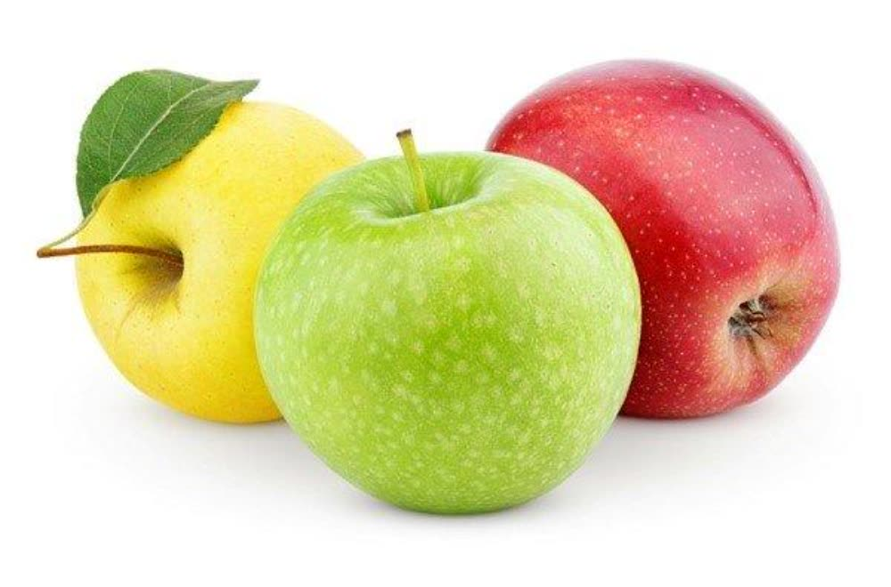

Reduce the risk of cardiovascular disease

Asthma

Cancer

Helps strengthen the body's immune system

Contains antioxidants

* Describe your day if you were this fruit:

If I were a fruit, I would be eaten. But I will try my best to grow to the best of my ability. To make my life better or the future will reach my goal. I will do like an apple. Because it contains vitamin C and soluble fiber in apples, it plays an important role in lowering cholesterol and helping to stabilize the blood pressure system. Even this one fruit, it is just a fruit by.

* That helps those who need to eat in times of hunger.
* But this fruit also needs someone to take care of it.
* We must dare to accept what it intends to happen​ the whether it is good or bad.

### Want to see yourself in 5 years.

I found myself at a bank that I wanted to do in 5 years. For the next 5 years, I plan to have my own business. Be a good manager in managing others.​Have a good job in my life. Have a house, have a lot of money. Want to have what i want. Expert in computer field. Having a house, a car, and a happy family and will help people who need our help. As we have the right business, we know how to help others. We must provide them with work experience. Will help the society to be more prosperous and social development. Success! Success is the achievement of goals that we have planned in the past.



“Where there is effort, there is success”

**Try to be successful**

**I can do ti.**